Here document and Here string

1) Convert a string to uppercase using:
a) Here document
b) Here string

Hint: tr a-z A-Z

a) Here document
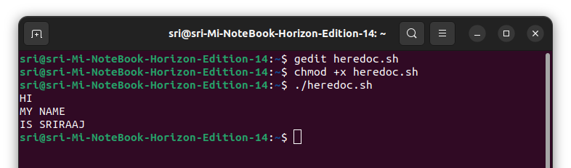
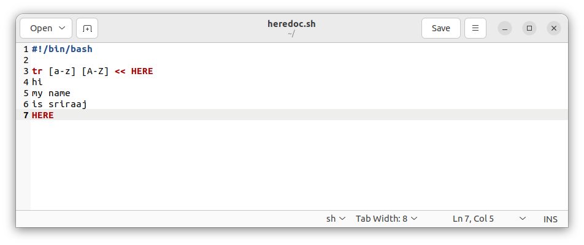

b) Here string
